Assignment2 : Application for the employees of a book store

Analysis and Design Document

Student: Lazăr Raluca-Florina

**Group: 30233**

Table of Contents

1. Requirements Analysis 3

1.1 Assignment Specification 3

1.2 Functional Requirements 3

1.3 Non-functional Requirements 3

2. Use-Case Model 3

3. System Architectural Design 3

4. UML Sequence Diagrams 3

5. Class Design 3

6. Data Model 3

7. System Testing 3

8. Bibliography 3

1. Requirements Analysis

# Assignment Specification

Use Java/C# API to design and implement an application for the employees of a book store. The application should have two types of users (a regular user represented by the book store employee and an administrator user) which have to provide a username and a password in order to use the application.

# Functional Requirements

The regular user can perform the following operations:

* Search books by genre, title, author.
* Sell books.

The administrator can perform the following operations:

* CRUD on books (book information: title, author, genre, quantity, and price).
* CRUD on regular users’ information.

Generate two types of reports files, one in pdf format and one in csv format, with the books out of stock.

# Non-functional Requirements

External non-functional requirements:

- Performance - The system should be able to be multi-tasking to allow multiple users, up to 40 simultaneous users per interface instance to interact with the system without having to wait on others to finish working with the system.

- Usability – The Application should be easy to use and also easy to learn by the user, which means that the user interface should be friendly and as simple as the user do not have to search for the action he wants to perform.

- Safety – The application should not cause harm, injury or damage when the user works with data involved in the actions he can perform.

- Security – The application should be accessible and usable only by authorized users, as long as both types of users have different account pages with different actions and privileges.

- Privacy – The system should be protecting personal information and undesired access to personal space.

2. Use-Case Model

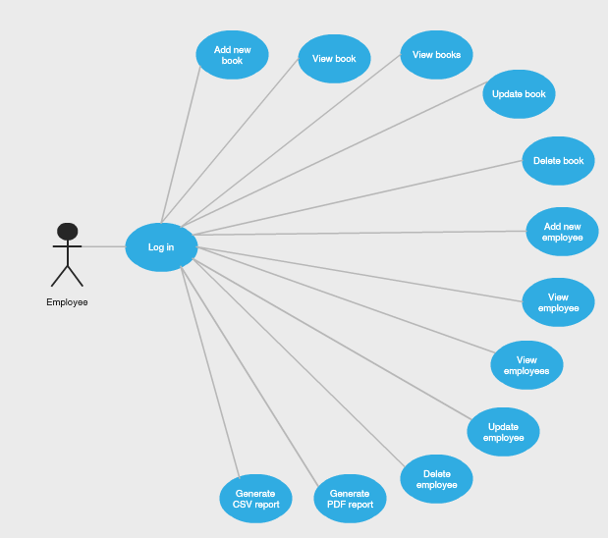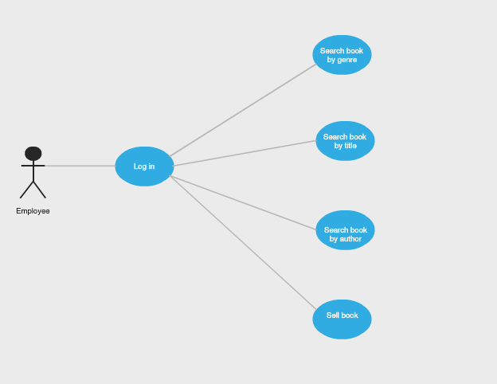

*Use case: Add new book*

*Level: User-goal level*

*Primary actor: Administrator*

*Main success scenario: 1. Administrator chooses his field in the main window of the application interface and presses OK.*

*2. Log in page for administrators pop up.*

*3. Administrator fill in the blanks for his personal username and password and presses OK.*

*4. System displays a list with the actions an administrator could perform.*

*5. Administrator chooses the ‘Add new book’ action.*

*6. A pane with 5 empty fields pop up.*

*7. Administrator fill in the information (title, author, quantity, genre and price) for the book he wants to register.*

*8. System registers the book and store the information in the xml document.*

*Extensions: 3.1 Log in data introduced is not valid – the system will show a message ‘Invalid username or password’.*

*6.1 Administrator can press the ‘Cancel’ button and return to the list of actions*

*7.1. Book data is not correctly introduced – the system will not store the wrong information.*

*7.2. Book already exists – it will not be stored again, the system will show an appropriate message.*

3. System Architectural Design

**3.1 Architectural Pattern Description**

I used for a well-structured graphic user interface implementation, the Model-View-Controller architectural pattern, which  separates the modeling of the domain, the presentation, and the actions based on user input into three separate classes.

The model manages the behavior and data of the application domain, responds to requests for information about its state (from the view), and responds to instructions to change state.

The view only manages the display of information.

Finally, the controller interprets the mouse and keyboard inputs from the user, informing the model and/or the view to change as appropriate.

**3.2 Diagrams**

Conceptual architecture:

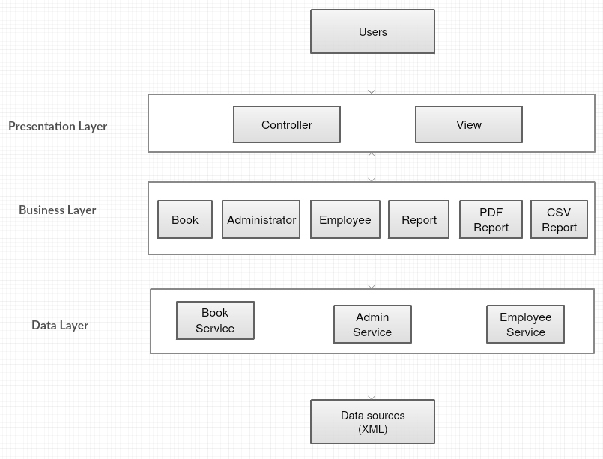

Package diagram:

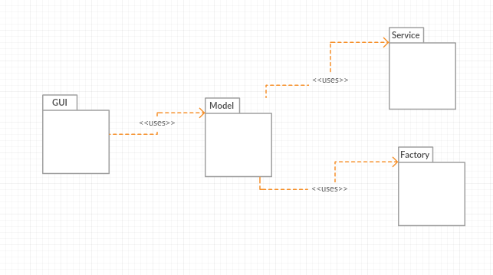

4. UML Sequence Diagram

Scenario: Sell book

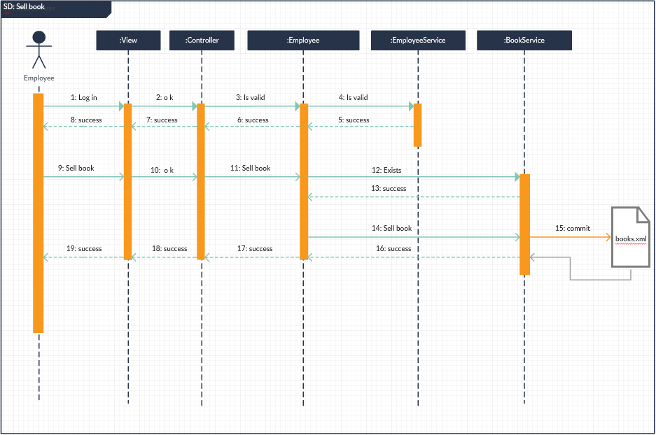

5. Class Design

**5.1 Design Patterns Description**

- Factory Design Pattern –

Factory pattern is one of the most used design patterns in Java. This type of design pattern comes under creational pattern as this pattern provides one of the best ways to create an object.

This pattern introduces loose coupling between classes which is the most important principle one should consider and apply while designing the application architecture. Loose coupling can be introduced in application architecture by programming against abstract entities rather than concrete implementations. This not only makes our architecture more flexible but also less fragile.

In this project, I implemented a factory which is able to build two types of Report. Therefore, my factory pattern follows the model implementation and structure of Report classes (the Report superclass and its subclasses PDFReport and CSVReport), through ReportFactory, PDFReportFactory and CSVReportFactory. Besides these, the Factory class has a method which generates the matching instance based on the string it has as input parameter.

The main advantages of Factory Design Pattern are:

* The creation of an object precludes its reuse without significant duplication of code.
* The creation of an object requires access to information or resources that should not be contained within the composing class.
* The lifetime management of the generated objects must be centralized to ensure a consistent behavior within the application

**5.2 UML Class Diagram**

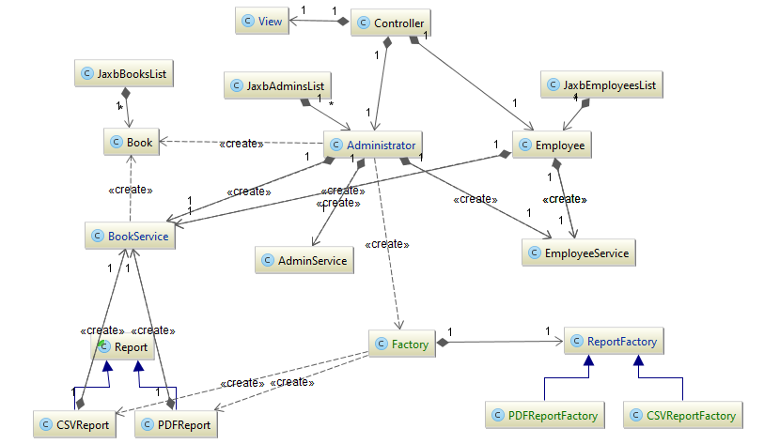

6. Data Model

*Administrator data:*

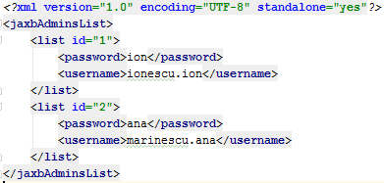

*Book data:*

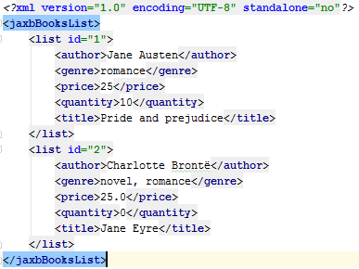

*Employee data:*

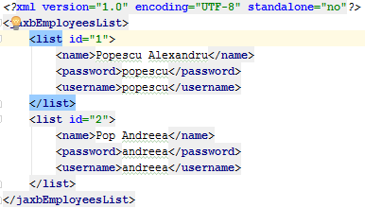

7. System Testing

First window, after the user runs the .jar file, should look like below:

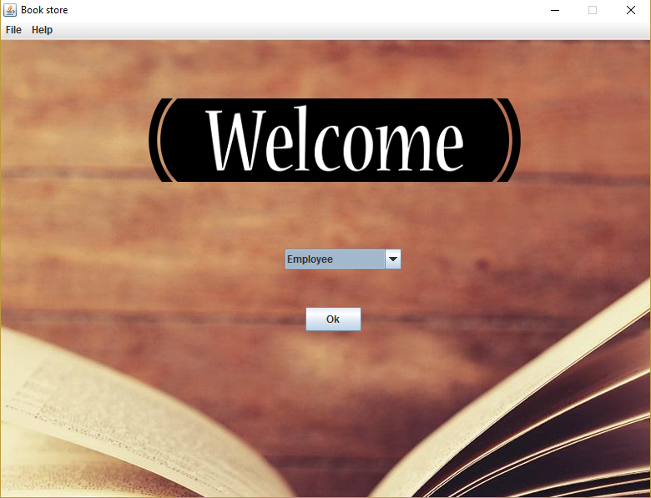

Next, depending on the user’s choice, the Employee or the Administrator window appears:

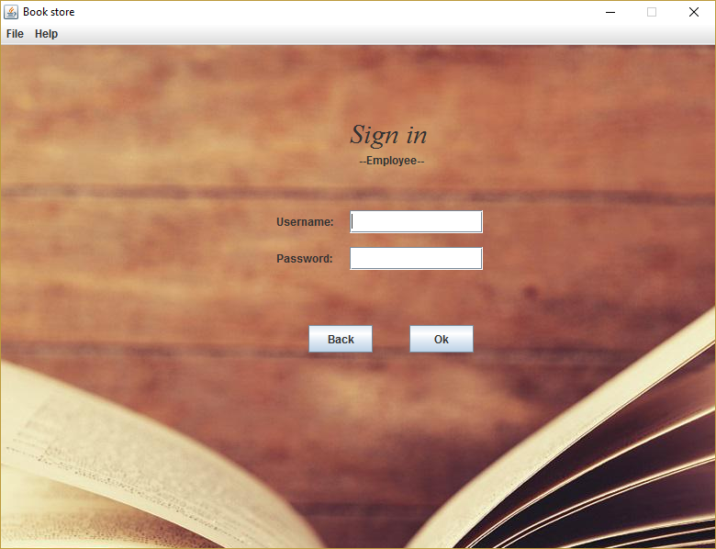

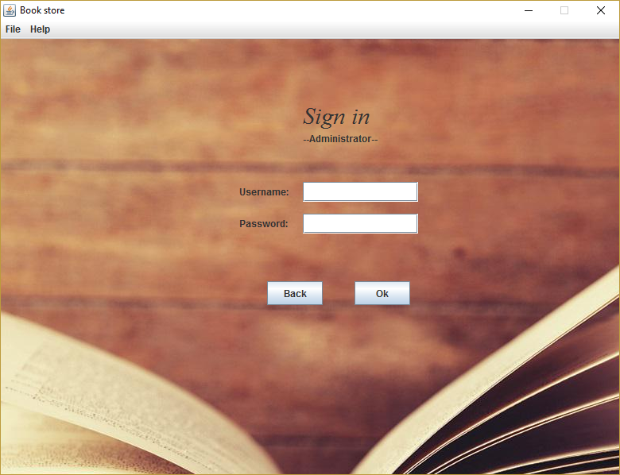

At the log in section, both Employee and Administrator have to fill in the correct username or password in order to go to the main page with the actions they can perform. If the data is not entered correctly, an alert message appears: “Invalid username or password”.

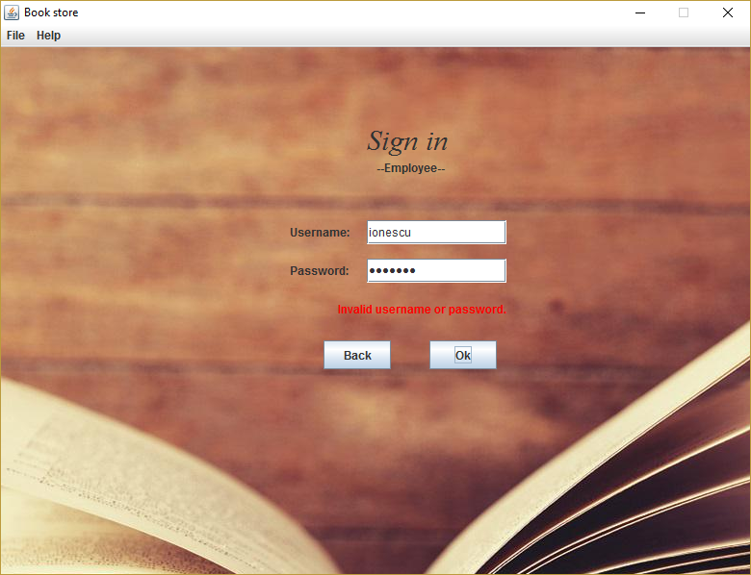

Though, if the user enter his own correct username and password, he will be able to access the application:

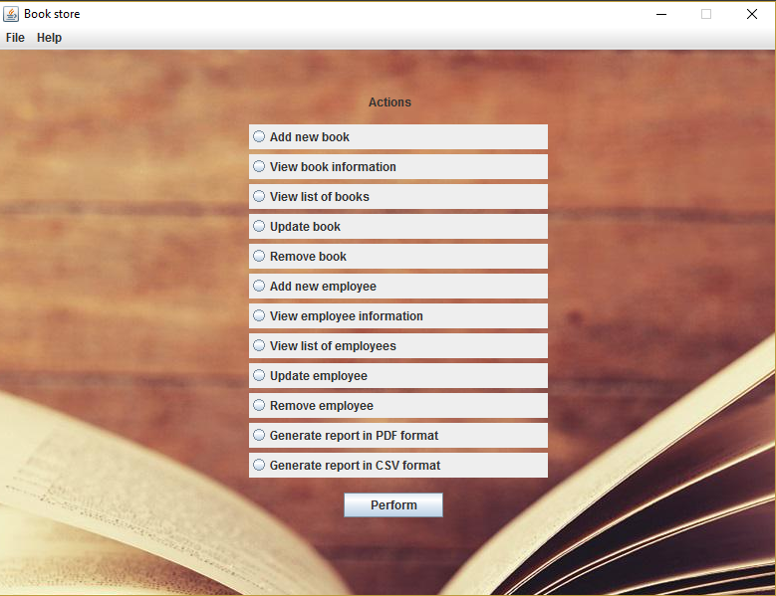

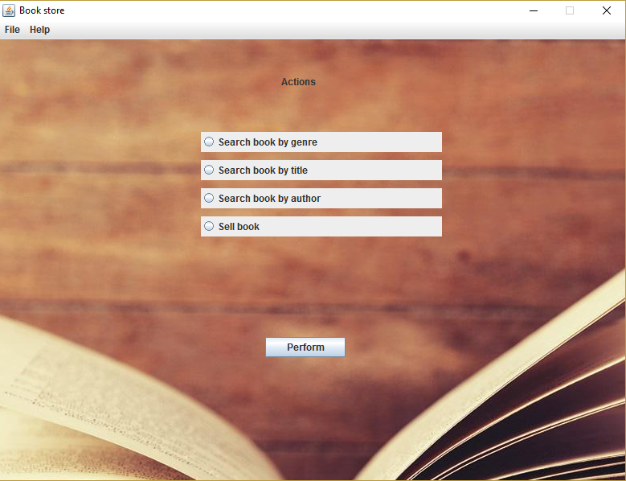

After this step, if the user logged in is an employee, he can perform actions from the list above. For example, if he wants to get a list of books of a certain genre, he will choose the first option, and he will have to fill in the genre he is searching for :

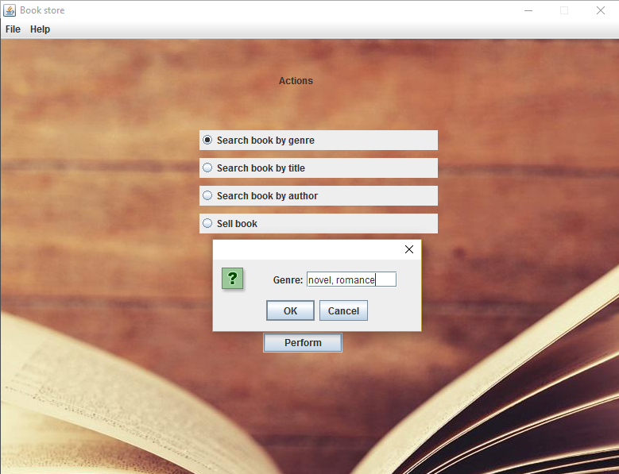

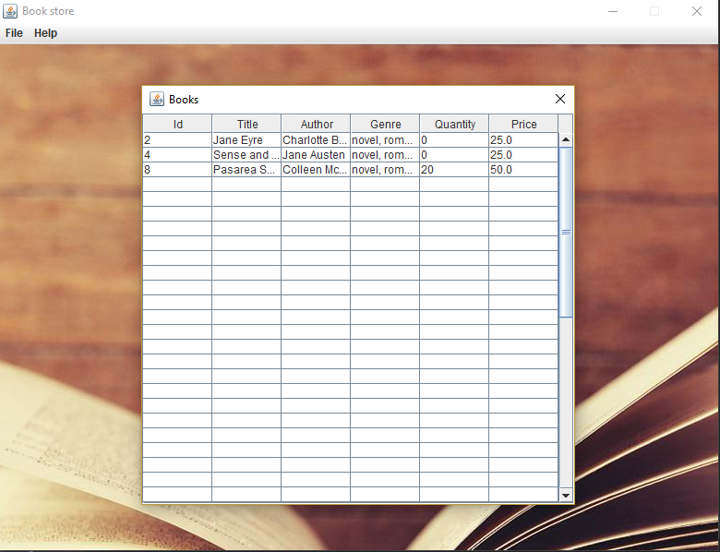

Considering the situation when the user want to sell a book, he have to fill in the required fields, as shown below:

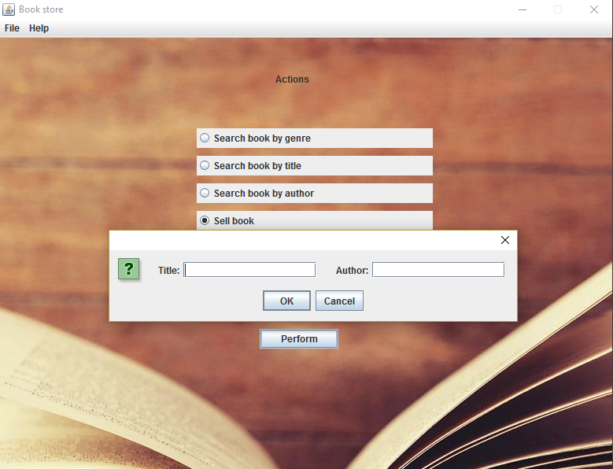

After the user presses the ok button, there are 3 possible situations: he succeeds to sell the book, the book does not exist or it is out of stock:

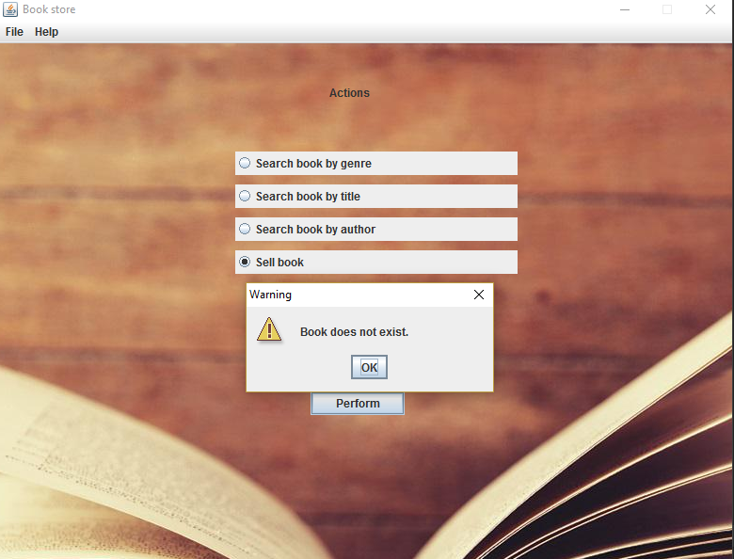

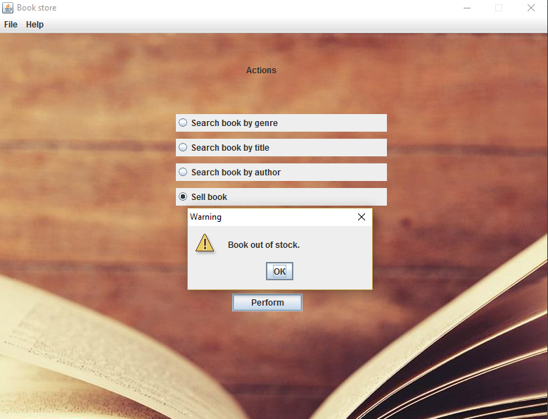

On the other side, the administrator user have much more actions he can perform. For example, if he have to add a new book, he should fill in all the information required for storing a book in the book store: title, author, genre, price and stock. If he manage to correctly introduce all the data needed to finish the operation, the new book is stored into the xml file, but if not, the book will not be added. Also, if he fill in the data from a book which already exists, he will get an appropriate message:

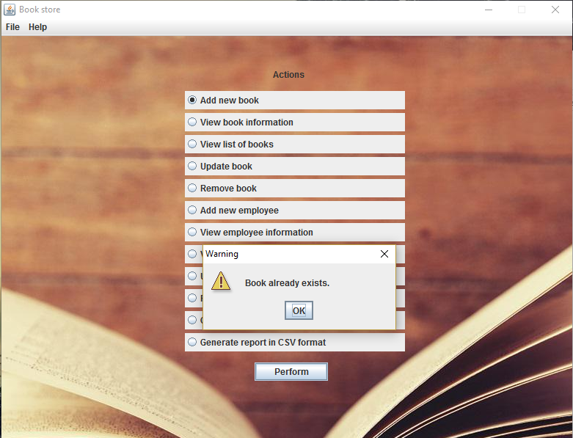

The administrator can also visualize the list of all books registered, with their details :

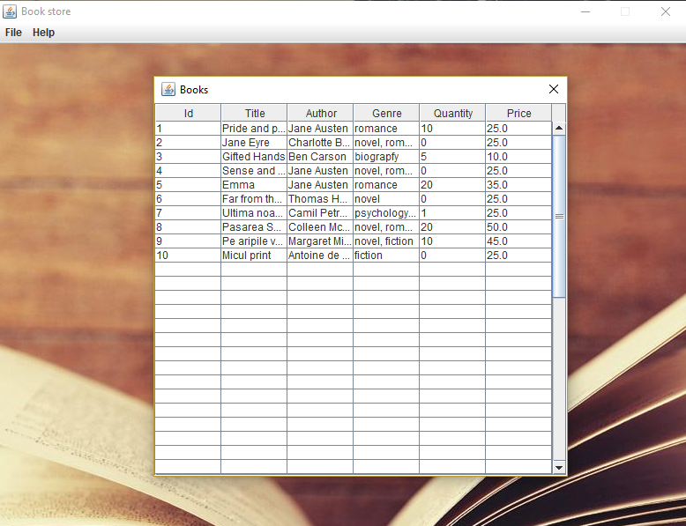

Also, for example, he can update data for an employee, having to introduce an existent id, then the window with data to be updated will pop up:

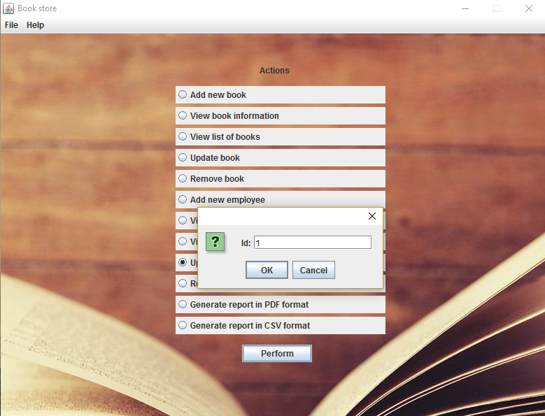

Last, but not least the administrator user can generate two types of reports with the books out of stock: one in PDF format and the other one, in CSV format. In this case, he only have to choose the corresponding option and he will get a confirmation message:

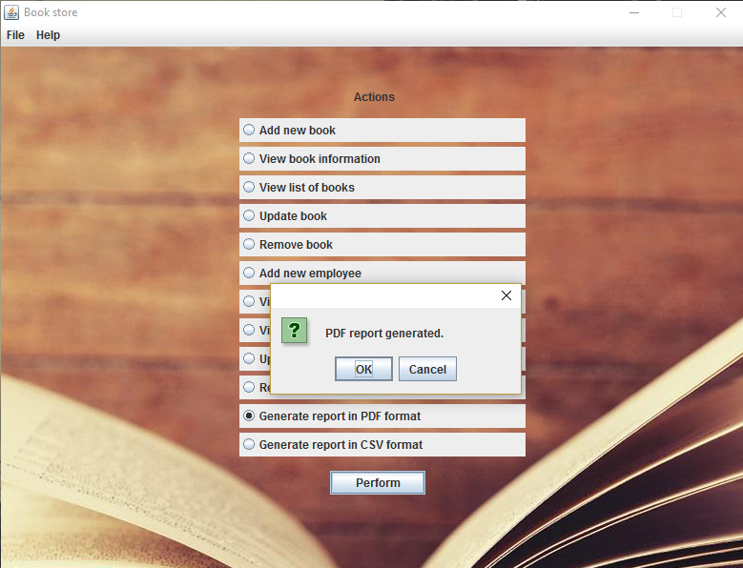

The reports in PDF and CSV format with the current list of books out of stock looks like below:

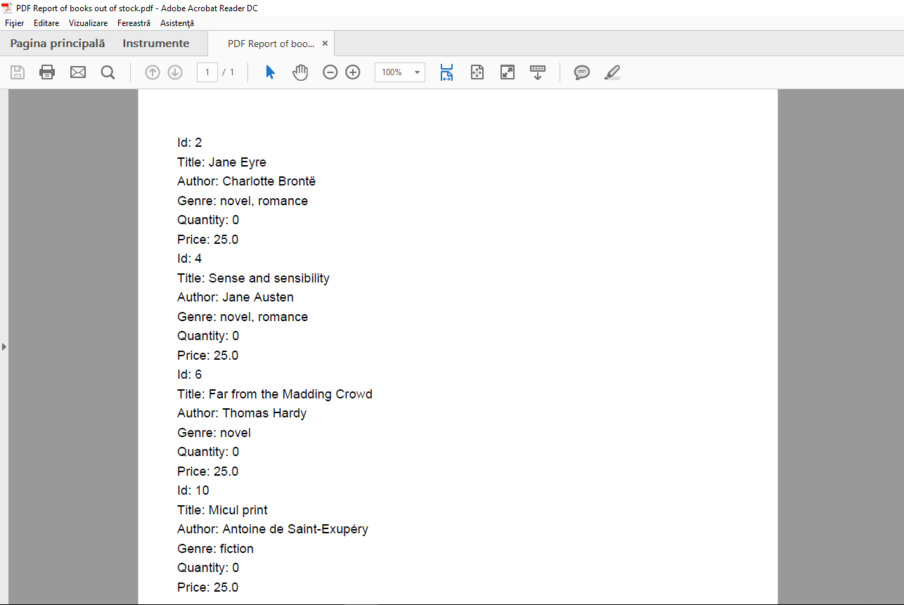

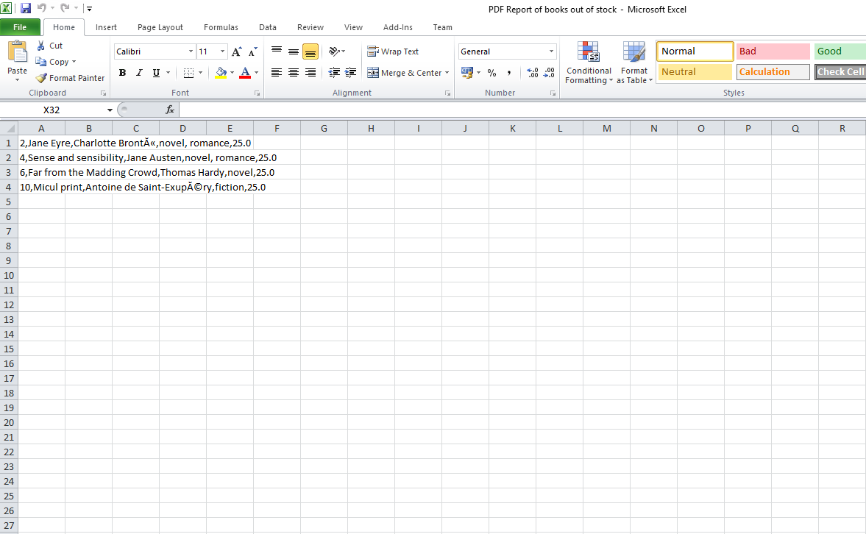

8. Bibliography

1. Patterns of Enterprise Application Architecture, By Martin Fowler, David Rice, Matthew Foemmel, Edward Hieatt, Robert Mee, Randy Stafford
2. .NET Application Architecture xxiv Guide, 2nd Edition
3. Software architecture patterns, Mark Richards.
4. <http://howtodoinjava.com/design-patterns/creational/implementing-factory-design-pattern-in-java/>
5. <https://www.tutorialspoint.com/design_pattern/factory_pattern.htm>